python preflight.py
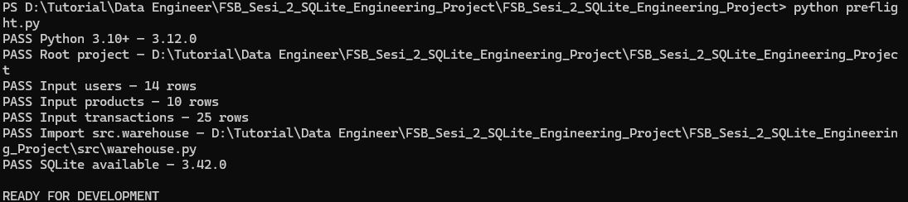
python quality_checks/01_environment.py
python quality_checks/02_schema.py
python quality_checks/03_master.py
python quality_checks/04_relations.py
python quality_checks/05_full_pipeline.py
python run_pipeline.py
python validate_delivery.py
